There are two ways to record in huddle – using a Note and using a Template. This guide covers using a Note to record.
- Log onto huddle and navigate to your workspace.
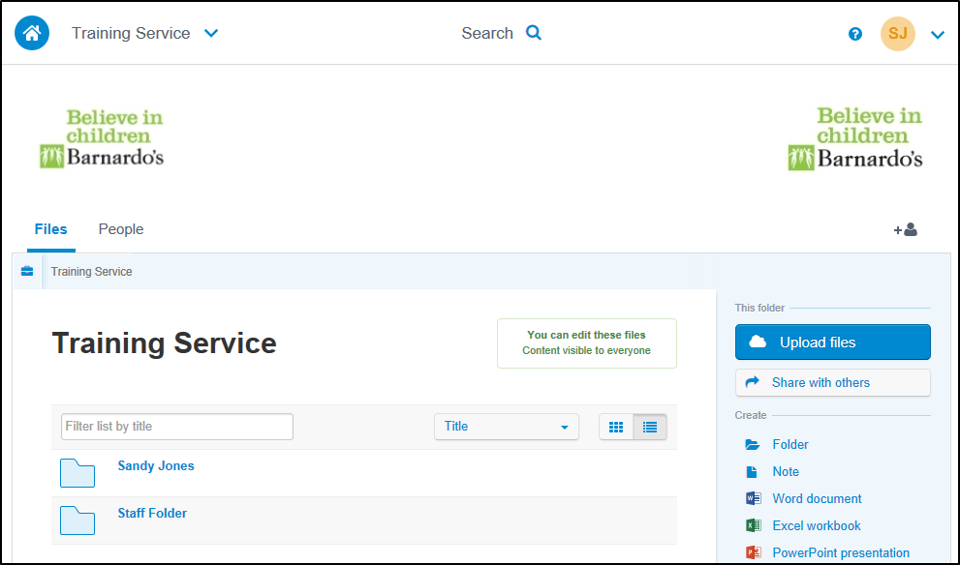
- Click on the folder with your name.
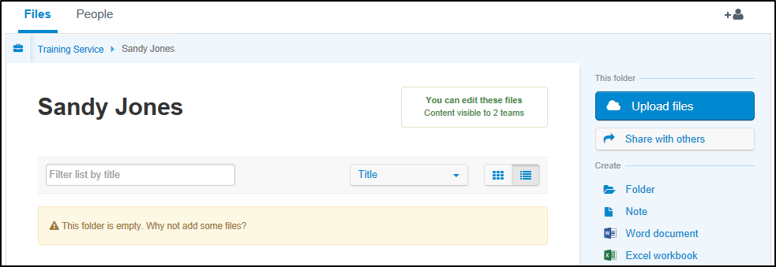

Adding a Note to the folder
- Click on Note in the right-hand panel.
- Click in the Title area and enter the date, followed by the service user or group the note applies to.
- Click in the note area and enter your recording text.
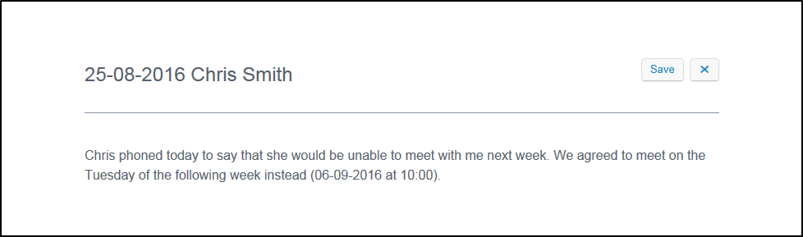
- Click the Save button.
- When the Save button text changes to Saved, click the X button.
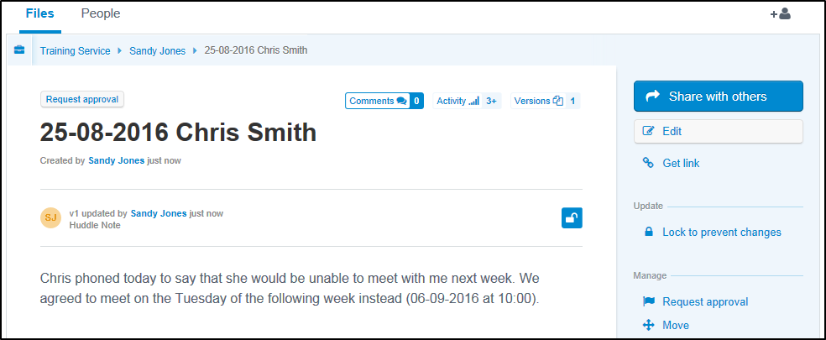
The next step is to share your recording with your Barnardo’s contact.

Sharing your Note with your Barnardo’s contact
- Click the Share this file button in the right-hand panel.
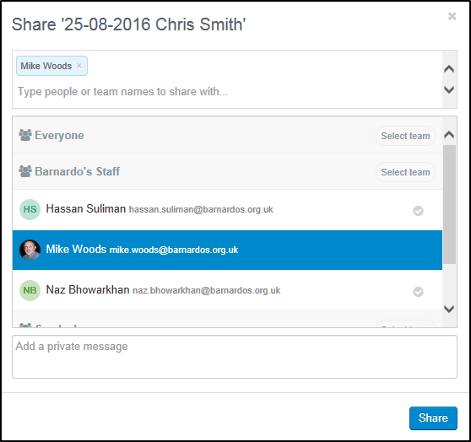
- Scroll down the list and find your contact, or type part of your contact’s name in the search box above the list.
- Select your contact – the name will appear in the search box.
- Optionally, add a message to the contact.
- Click the Share button.
- When the Share button changes to Done, click it to close the share window.

What Now?
If you have finished recording you can sign out of huddle. If you have more recording to do you can return to your folder by clicking your name in the row of links above the note title.

