There are two ways to record in huddle – using a Note and using a Template. This guide covers using a Word Template to record.
- Log onto huddle and navigate to your workspace.
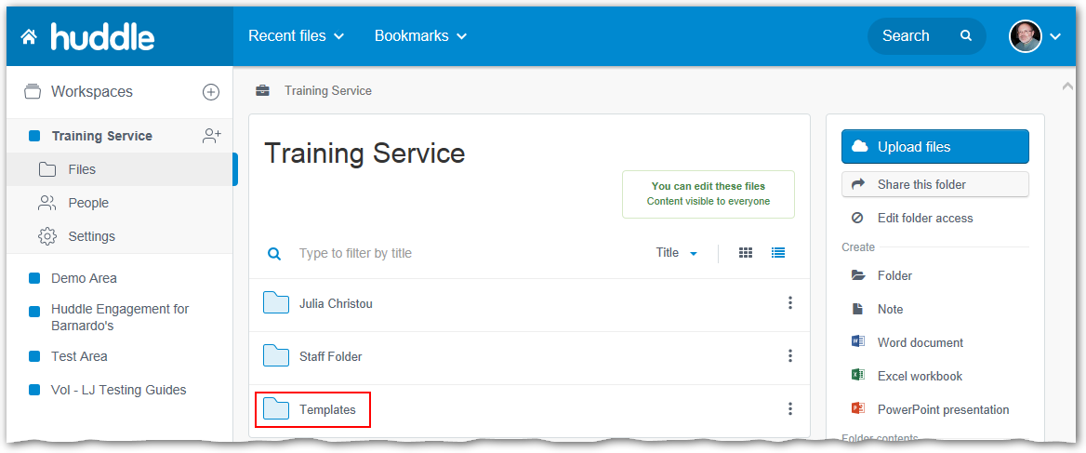
- Click the Templates folder.

Copying the template to your folder
Before you can record in a template you must first copy the one you need from the Templates folder into your named folder. Your Barnardo’s contact will let you know which template you need to use.
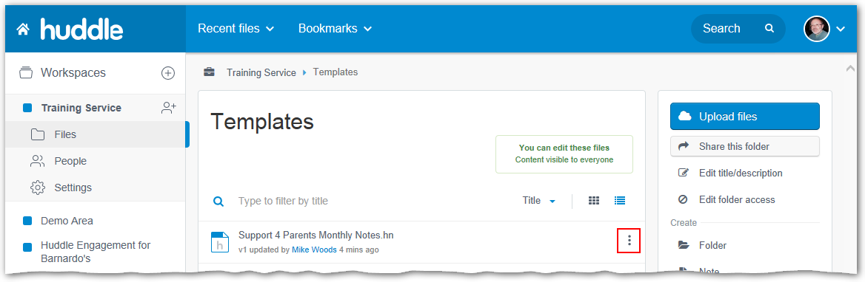
- Click the three-dot button to the right of the relevant template.
- Select Copy from the menu that appears.
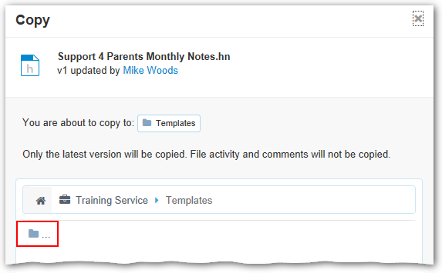
- Click on small grey folder button below the workspace name.
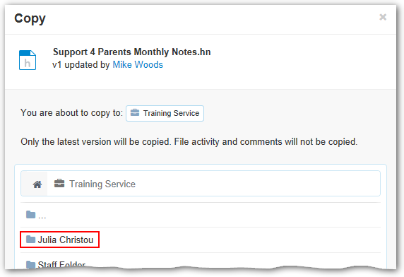
- Click the folder with your name.
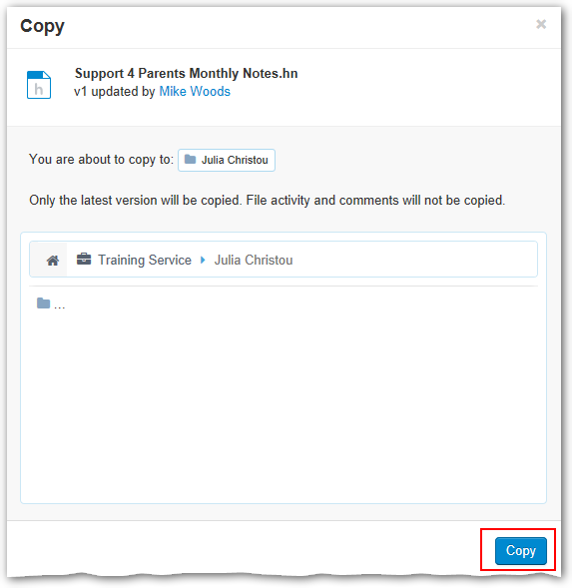
- Click the Copy button.
- When the Copy button changes to Done, click the Go there now button that appears to its left.
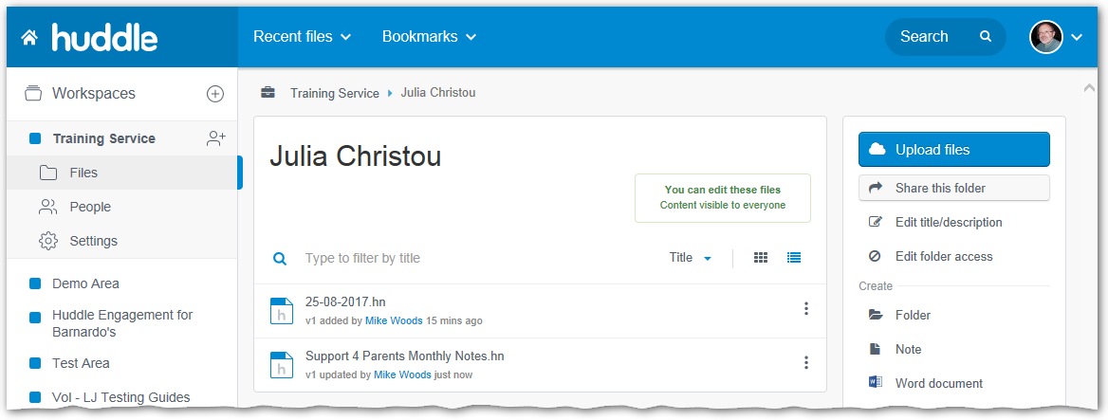
Now you have a copy of the template in your folder you need to edit it to add your recording.

Editing the template
- Click the name of the template to view the contents.
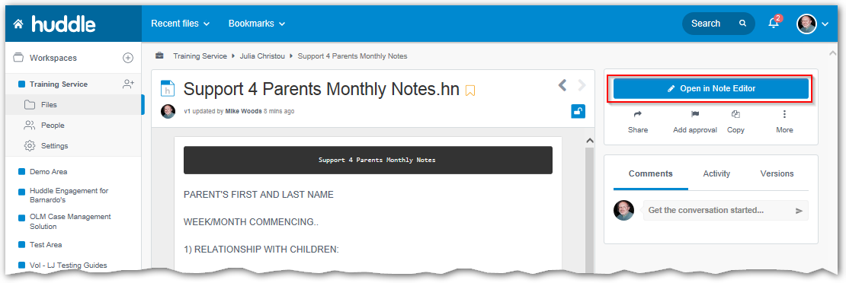
- Click the Open in Note Editor button in the right-hand panel.
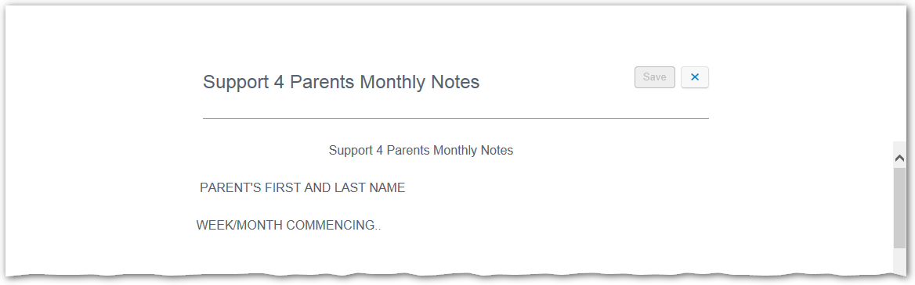
- Edit the title to be the date followed by the service user or group the note applies to.
- Edit the main body of the template to add the relevant information.
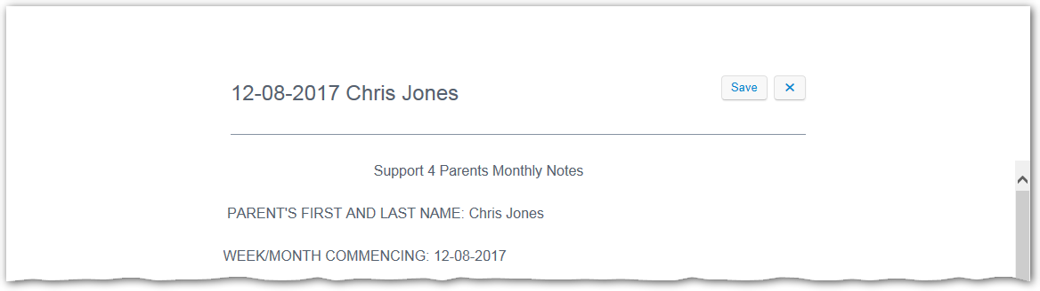
- Click the Save button.
- When the Save button text changes to Saved, click the X button.
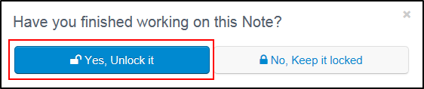
- If the “Have you finished…” notice appears, click the Yes, Unlock it button.
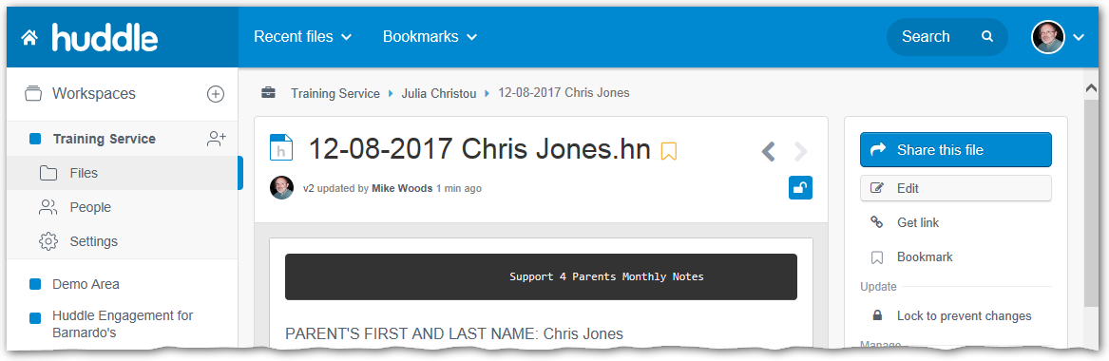
The next step is to share your recording with your Barnardo’s contact.

Sharing your recording with your Barnardo’s contact
- Click the Share this file button in the right-hand panel.
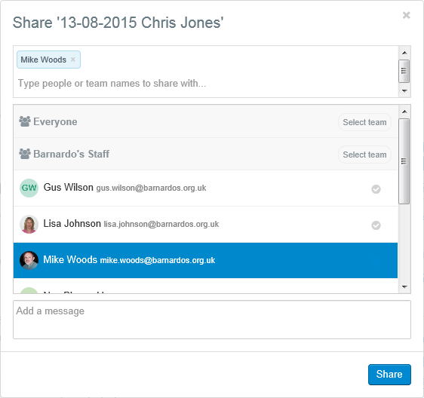
- Scroll down the list and find your contact, or type part of your contact’s name in the search box above the list.
- Select your contact – the name will appear in the search box.
- Optionally, add a message to the contact.
- Click the Share button.
- When the Share button changes to Done, click it to close the share window.

What Now?
If you have finished recording you can sign out of huddle. If you have more recording to do you can return to your folder by clicking your name in the row of links above the note title.

