When someone invites you to join a huddle workspace, you will receive an invitation email. The email will contain the name of the person who invited you and also the name of the workspace you are invited to join.
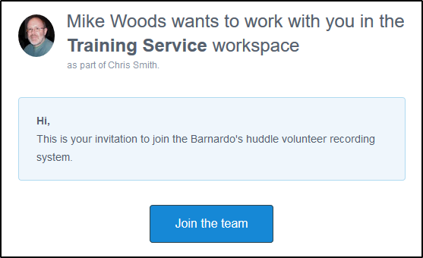
To accept the invitation:
- Click the Join the Team button.
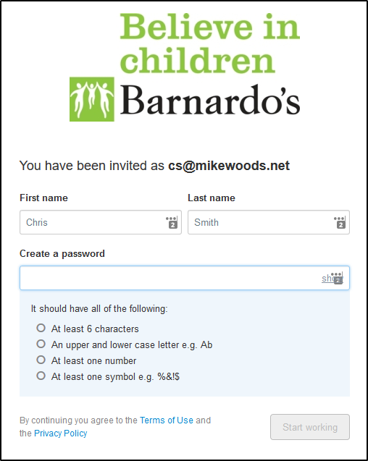
- Enter your First Name and Last Name.
Create a password. The password you choose must:
- Be at least six characters
- Contain a mix of upper and lowercase characters
- Include at least one number
- Include at least one special character such as ! $ # %
Once you have completed the required fields:
- Click the Start Working button.
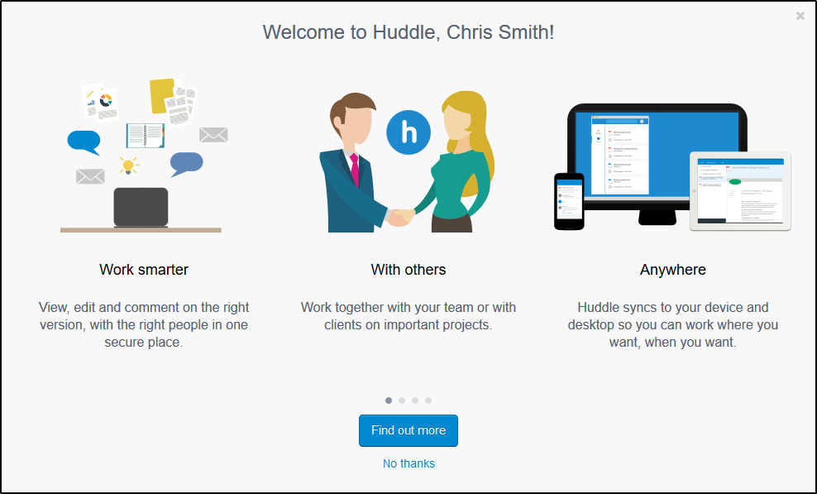
You can view the information screens with the Find out more button, or click No Thanks to skip this and log straight in.

Understanding the huddle workspace
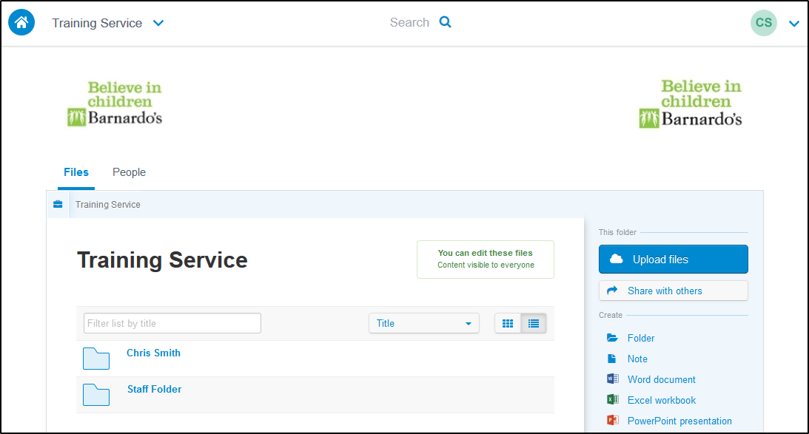
The name of the workspace is displayed prominently above the folders in the central area. This will normally be the name of the Barnardo’s service you will be working with.
Note: When you log into huddle subsequently you may not be taken straight to your workspace. Is so, you can get to it using the drop-down list in the top-left of the screen.
Use the buttons in the block to the right to add your notes and share these with your Barnardo’s contacts.
The folder with your name is where you should view and add/edit your files (depending on what permissions you have been given).
The other folders contain files that you may need to help you with your recording. You will not normally be able to edit these files.

Signing out of huddle
For security reasons you should always sign out when you have finished working on huddle.
- Click on the drop down arrow in the top-right corner of the huddle screen.
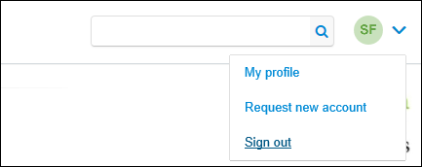
- Select Sign Out.

Tips
Once you have registered add the huddle sign in screen as an internet favourite for quick and easy access next time you need to log in.
The web address of the huddle site is https://barnardos.huddle.net/
If you forget your password at any point use the Forgotten your password? link on the sign in screen to reset this.
To add a profile picture select My Profile from the same menu as the Sign Out option. Scroll down the profile page and use the Browse button to load a picture from your computer.

