Use the following instructions for removing the PIN, an iTunes account and icloud for apple smart devices or a Google Account for android smart devices.
This shouldn’t take you long and will save us a lot of time and effort. It will also mean your iTunes or Google account details are protected.
There are more details (including address labels) on how to return IT equipment in b-hive.
Note: Please include the charger with your smart device

Steps:
- Remove your iTunes or Google account (the links will direct you to the instructions below)
- Remove the pin protection from the device

Android device – remove Google account

- Select Settings and tap on Accounts
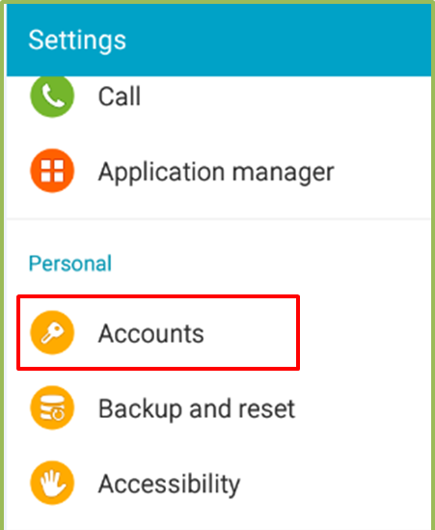
- Tap Google
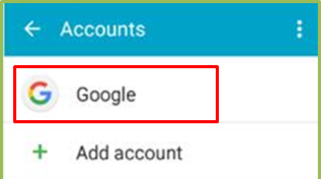
- Tap the Barnardo’s account
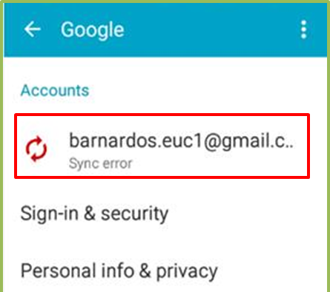
- Tap the Menu (3 dots top right) and select Remove account
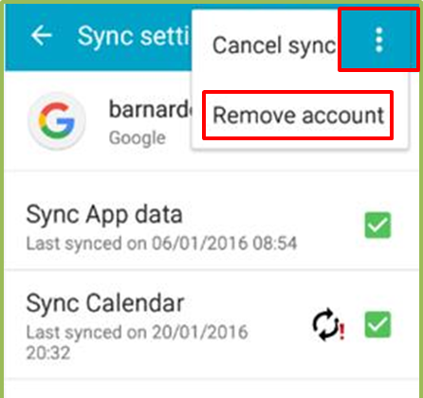
- Tap on REMOVE ACCOUNT
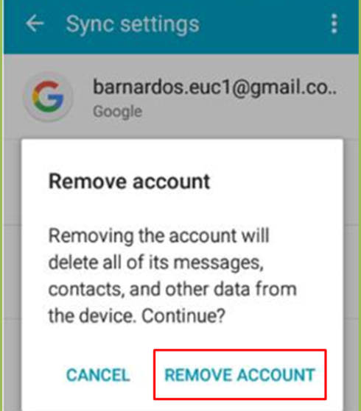
- Tap on OK
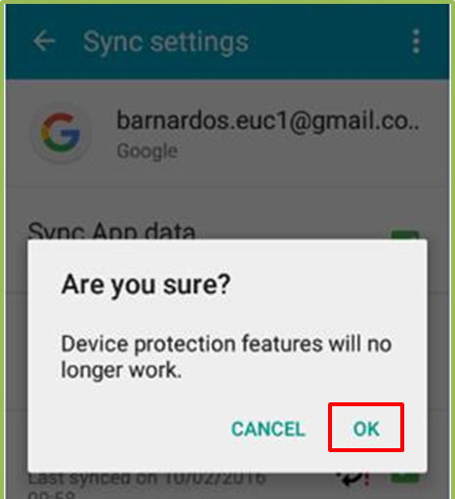
- Enter your PIN and tap on Done
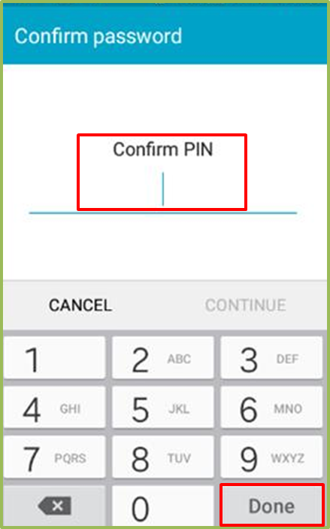

Note: Remember; now remove the pin protection from the device.

iOS device – remove iTunes account
- Go to Settings and select iTunes & App Store
- Select Sign Out from the list

- Select your Account then click Sign out
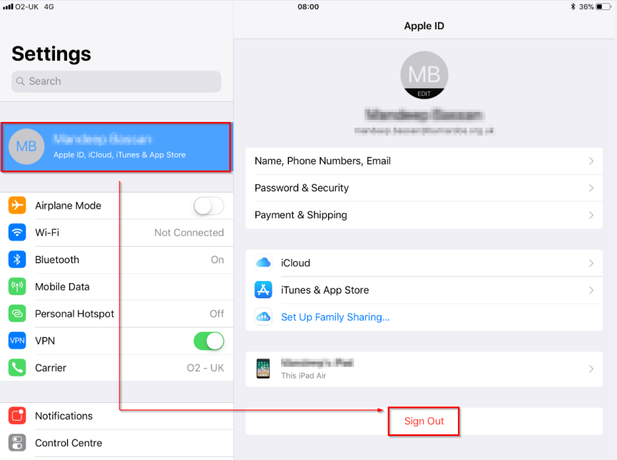

Note: The display for this may vary from iPad to iPhone device screen
- If the Find my Phone feature has been enabled, enter your password and tap Turn Off
- Tap Sign Out

Note: Remember; now remove the pin protection from the device.

