When you edit a document that is stored on Content Server, a new version of the document is added. However, any previous versions are still stored and accessible. To view the previous versions of any document:
- Navigate to where the document is stored on Content server.
- Click on the Function button to the right of the document name (The Quick Navigation with Favorites document in the example below).
- Select Versions from the Properties menu, as illustrated below.
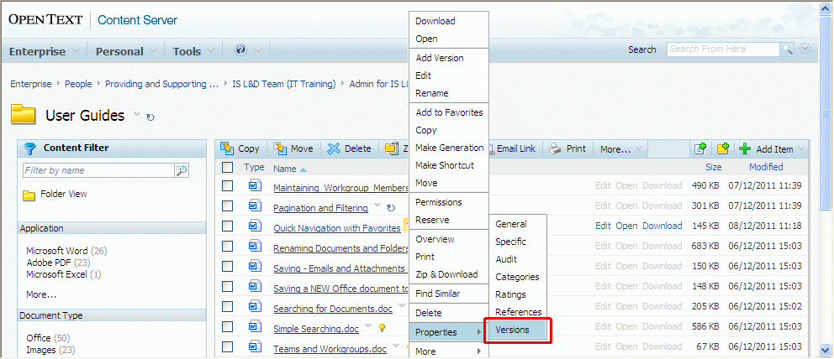
This screen lists all of the previous versions of the document, with the latest one at the top. You can view any version by clicking on its name.
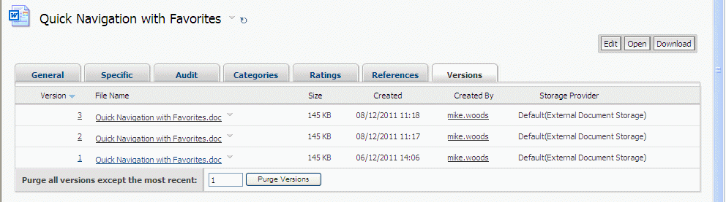
Tips for Working with Versions
- If you want to delete the most recent version(s) to return to a previous version, click on the Function button for the latest version and choose Delete Version. One example of where this might be useful is if someone has accidentally saved information into a blank form and you want to revert to the blank version.
- If you have a large document that is updated regularly, you can save storage space by regularly purging all but the last few versions. Enter the number of versions you want to retain in the Number to Keep field and them click on the Purge Versions button. This will permanently delete the older versions.
- If you want to return a previous version to the “top” of the version list, but retain all the old versions as well, click on the Function button for the version you want to restore and choose Open. Then use Save As from the Enterprise Connect tab to save the document back to the same location with the same name.
Note: If the document is in a Service User Recording area this is the ONLY way to return a previous version, as you cannot delete or purge versions in SUR areas.

