If you want to keep emails for longer than 90 days, you must save them into Content Server. The easiest way to do this is drag and drop into a folder in Content Server.

Adding emails to Content Server
Tip: If you have previously added the folder in Content Server where you want to store your emails to your Favorites, this process will be much faster.
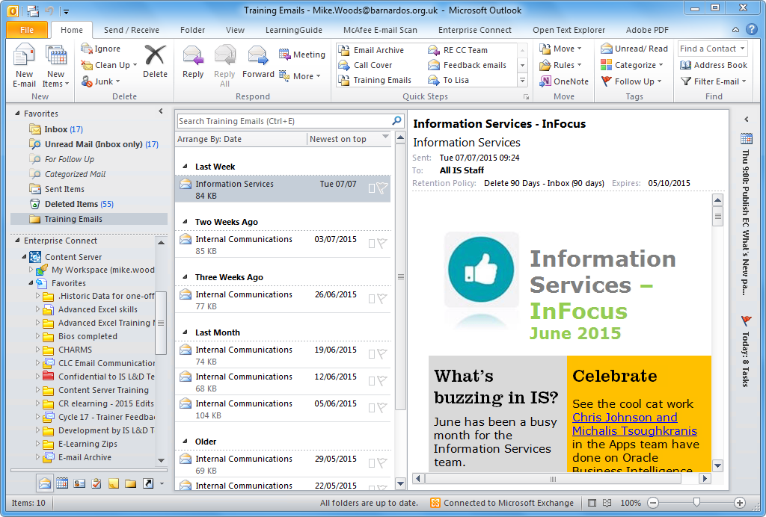
At the bottom of the left-hand panel in Outlook you will find an Enterprise Connect folder. You can use this to add emails to folders on Content Server:
- Open the Enterprise Connect folder by clicking on the small triangle to its left.
Note: Do NOT click on the name of the folder (or any of the subsequent folders) as you open the folder tree, or you will change what is shown in the central panel. If you DO accidentally click on a folder name you can get the email list back by clicking on Inbox at the top of the left panel.
- Open the folder called Content Server in the same way.
- If the folder you need is in your Favorites, open that folder in the same way. Otherwise open the Enterprise Workspace folder and then navigate down to the folder you need from there.
- When you can see the folder you need, click and drag the email to be saved from the list of emails in your Inbox and drop it onto the folder.
The email will disappear from your Inbox and will be saved into the Content Server folder you dropped it onto. This will include the full email, plus any attachments.
At this point you will also be prompted to add any Category information, depending on where in Content Server you are saving the email.
Tips
If you drag with the right mouse button you will get a menu of options when you release the email, allowing you to either Copy or Move the email (or Cancel if you have dropped it in the wrong place!).
If you only want to save an attachment, you can drag just the attachment from the view panel and drop it onto a folder in Content Server.
If you want more precise control (or have difficulty with Drag and Drop), you can double-click on an email to open it and use the Copy Message or Copy Attachments buttons to do the same processes.

Viewing your Saved emails
Once you have moved or copied an email into Content Server you can view it by opening Content Server and navigating to the folder you saved it to.
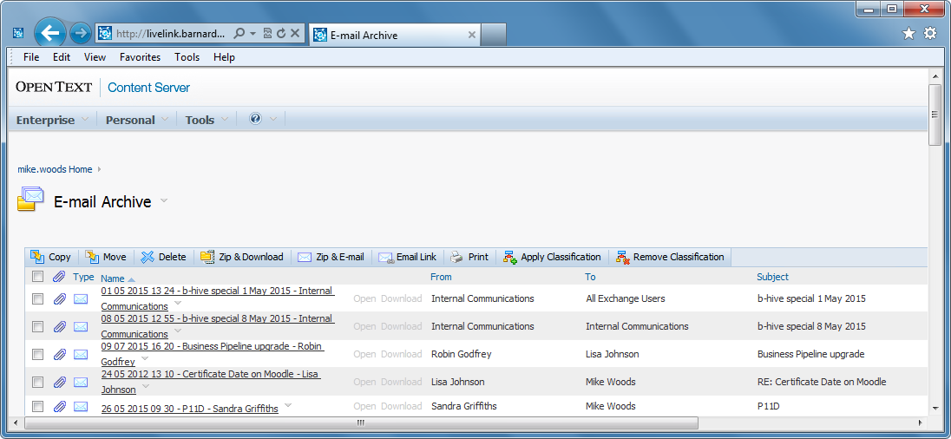
However, you can also view and work with saved emails from within Outlook. To do this.
- Open the Enterprise Connect folder tree down to the folder containing the email, as described above.
- Click on the name of the folder.
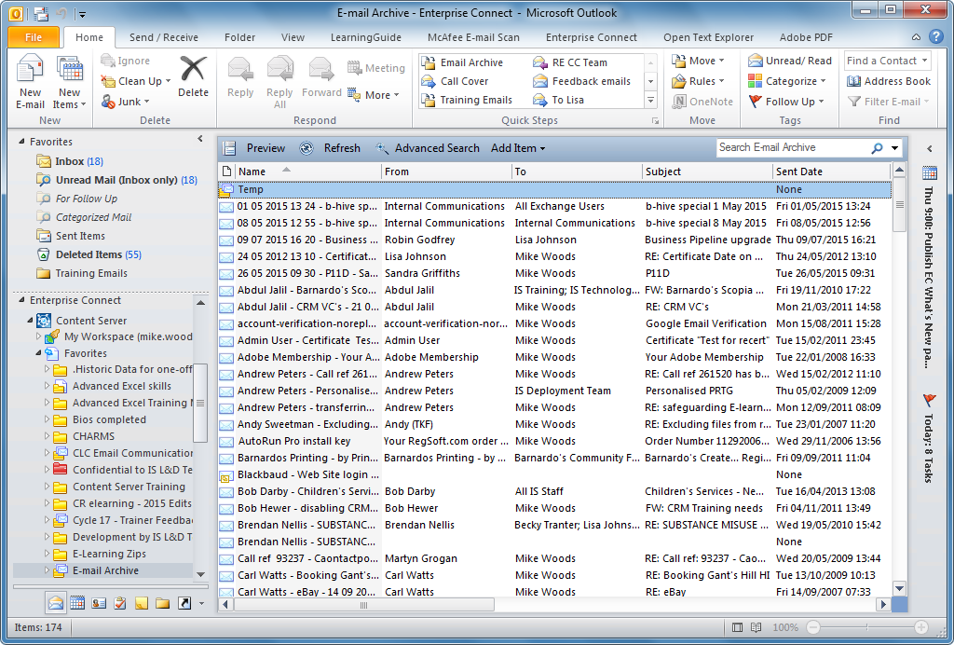
You can now see the emails in that Content Server folder. If you double-click on an email it will open as normal and you can reply, forward, open the attachments etc.
After you have finished with the emails here you can return the view to normal by clicking on Inbox at the top of the left-hand panel.

