There are a number of steps needed to create a volunteer folder on huddle and it is important that you follow them all as detailed below so that the right people have access to the information stored in the folder.

Creating a volunteer folder
- Navigate to your workspace.
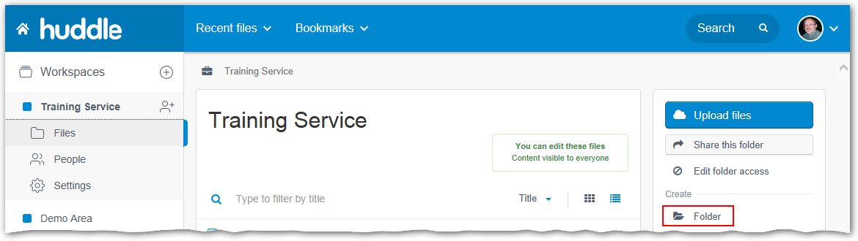
- Click Folder from the Create area.
- Enter the name of the volunteer in the Name field.
Security Tip: The name of this folder (but nothing inside it) will be visible to all of the volunteers using the workspace. If this is an issue for you, you could use initials instead of the full name, e.g. name the folder JC instead of Julia Christou in the above example.
- Click the Create button.
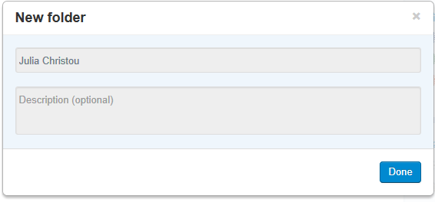
- Click the Done button.
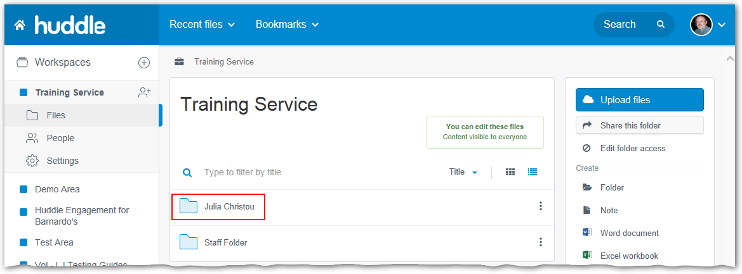
The new folder appears in the folder list. You can now move on to the next step; assigning the folder to a team.

Assigning the new folder to a team
In order to ensure that the volunteer only has access to their own folder, you now need to create a team with the same name as the volunteer, which you can then assign appropriate folder permissions to.
- Click on the folder name for the newly created folder to open it.
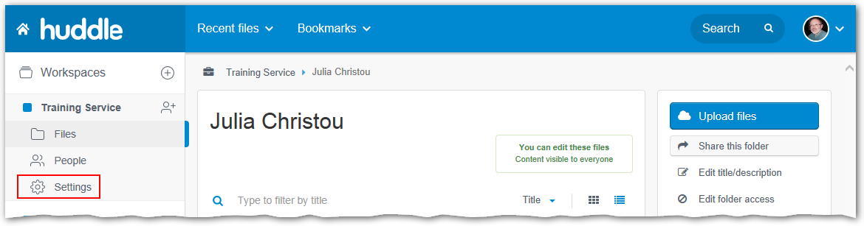
- Click on the Settings tab in the left-hand panel.
- Select the Teams option.
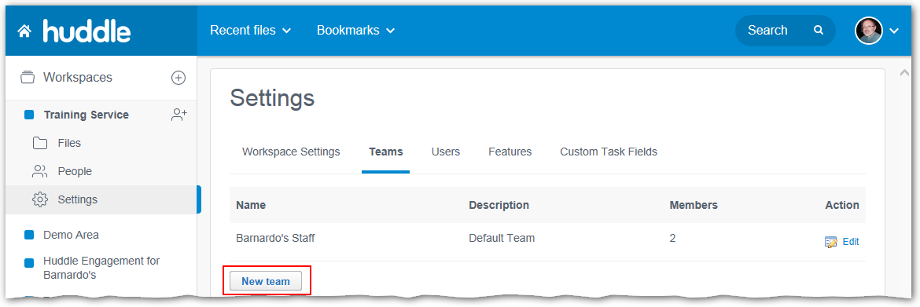
- Click the New Team button.
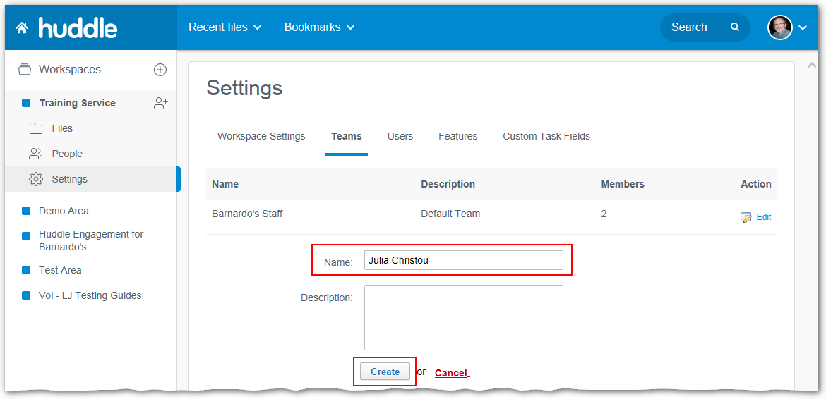
- Enter the volunteer’s name in the Name field.
- Click the Create button.
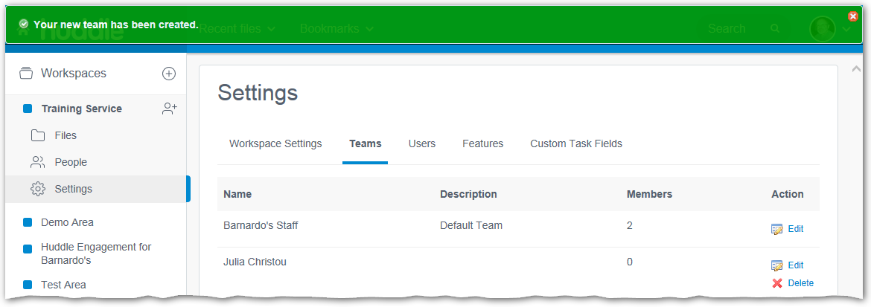
You have now created a new team for the volunteer folder – you can now move onto the next step, which is to assign the correct permissions to this team.

Assigning the correct folder permissions
- Click on the Files tab to return to the workplace.
- Click on the folder name for the newly created folder to open it.
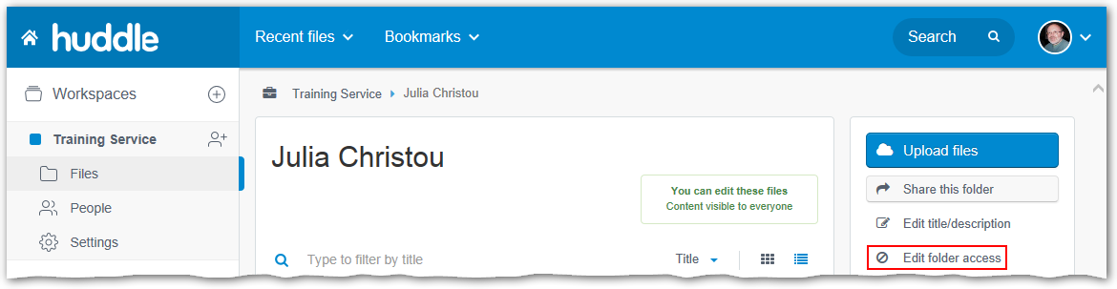
- Click on Edit folder access in the right-hand panel.
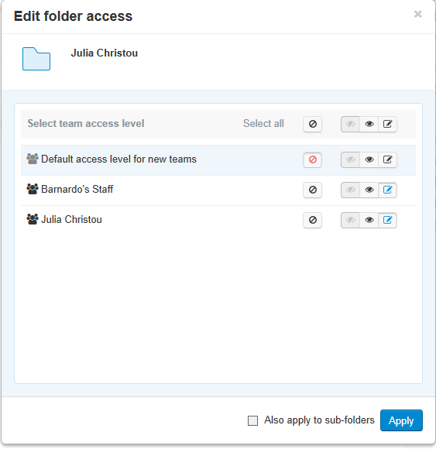
There are four permission levels – Viewer (the eye), Viewer online only (the crossed through eye), Editor (the pencil) and no access (the no entry sign). You should assign access permissions as follows:
- First, select No Access next to Select All at the top of the list.
This ensures that all the teams listed start with no access. Then you can assign access as needed:
- Default access for new teams: No access.
- Barnardo’s Staff: Editor.
- This volunteer’s folder: Either Viewer or Editor, depending on whether you want to allow them to edit the folder contents.
- All other teams: No access.
Once you have assigned the permissions as above:
- Click on the Apply button.
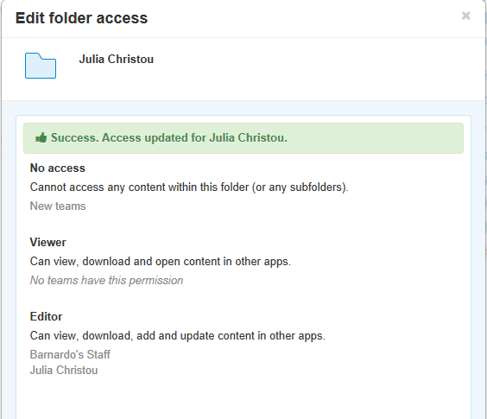
- Click the Done button.
You have now set up the folder permissions and can move on to the final step – inviting the volunteer to huddle so they can access their folder.

Inviting the volunteer to huddle
- Click the People tab in the left-hand panel. This leads to a list of all the exiting teams.
- Scroll down the page until you find the team name for the new user.
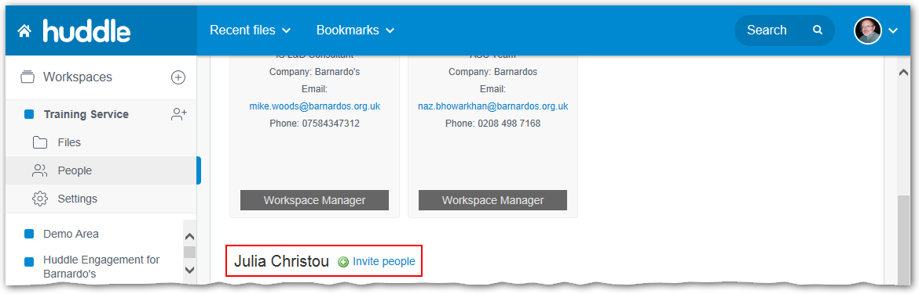
- Click the Invite People button to the right of the user’s name.
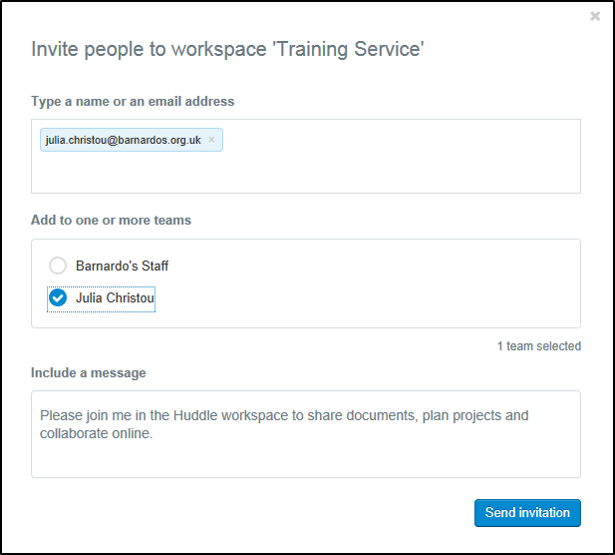
- Enter the full email address of the volunteer you are inviting into the first field.
- In the Add to one or more teams area, select the team named for the volunteer from the list.
- Edit the Personal message if you wish
- Click the Send Invitation button.
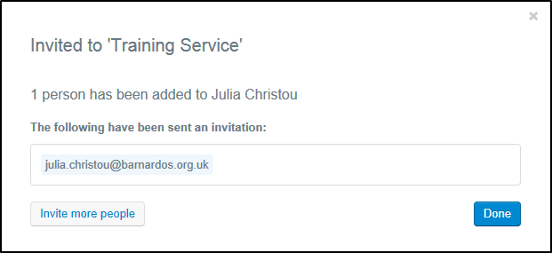
- Click the Done button.
You can now click on the Files tab in the right-hand panel to return to the workspace
Important: You should remove volunteers when their access is no longer required. The details of how to do this can be found on the huddle b-hive page.

