When you log a ticket on FirstPoint you are asked to categorise it. This guide gives examples of the type of ticket with the correct type and category. Choosing the correct options will make dealing with your ticket quicker and simpler.
Note: If you wish to order any IT equipment, applications or new IT logins, choose My IT Store from the FirstPoint home page. This guide covers just logging a ticket.

Logging a Ticket
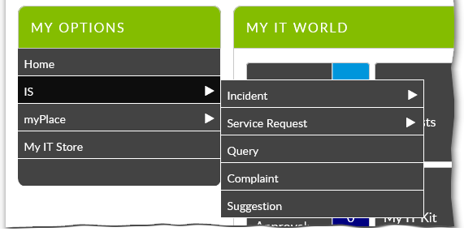
There are a number of ticket types. Some of them are fairly self-explanatory. Under IS you have the following ticket types
Question: Use this to ask a question about an IT system or application, e.g. “How do I change my IT login password?”
Complaint: Use this to make a complaint about the service IS deliver, not for a problem with equipment or applications – those are Incidents (see below).
Suggestion: Use this to make any IT related suggestions.
There is a separate menu entry for myPlace. Use this if you have any incidents or questions about myPlace, Direct Input or iExpenses.
Note: Do not call the IS Service desk about myPlace incidents – always use this option in FirstPoint. The People Systems team will be in contact.
The Incident and Service Request items in the IS menu have further options.

Incident
This is anything that appears to have gone wrong with an IT service or device. Examples are:
- A system is not available, e.g. Content Server or Oracle
- My network connection isn’t working
- My mobile phone or tablet is not getting signal
- I dropped my laptop and now the keyboard doesn’t work
- I need a password to be reset e.g. eLearning, DAMs
Note: The Incident type has a series of categories. These are covered later in this document.

Service Request
This is anything you need IS to do for you. Examples are:
- Please run a report for me
- Please unblock an email
- How much was our telephone charges in July?
- I need to change the cost code a telephone is charged to
- Please delete something (e.g. a file from Content Server)
- Please amend something (e.g. an Oracle report)
- I need an email restored for legal reasons

Incident Categories
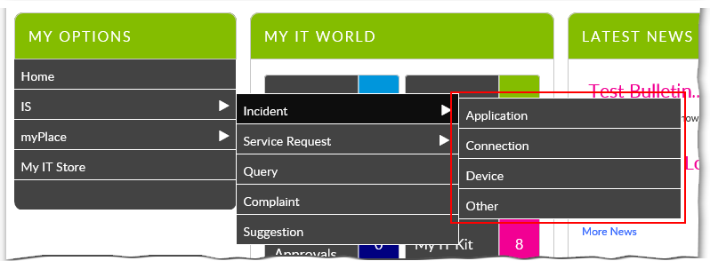
If you choose Incident as the ticket type, you are given a series of categories to choose from. Use the Other category if you are unsure which to use.
Tip: Whichever category you select, please include the CI number of your computer (from the embossed label) in the description of the incident.

Application
Applications are software and systems. Examples are:
- A system is not available, e.g. Content Server or Oracle
- Microsoft Word will not start
- WorxStore is not letting me download an app
- I get an error message when I try to open Citrix

Connection
Connection covers all the ways a device is connected to the internet or any other network. For example:
- Nobody can connect to the Guest WiFi
- I can’t connect to the WiFi at home
- I don’t get a dialling tone on my landline
- Internet Explorer can’t connect to the internet

Device
A device is a physical piece of equipment. Something you can touch e.g. laptop, keyboard, printer, mouse. Examples are:
- I dropped my laptop and the keyboard doesn’t work
- The printer is flashing ‘Error 45’
- The screen on my smartphone has frozen
- The monitor is blurry
Tip: If you need more help using FirstPoint, see the other learning resources on b-hive, or call the Service Desk on 0208 498 7777.

