When a volunteer adds any recording to huddle, they will share it with you, and you will receive an email alerting you to this.
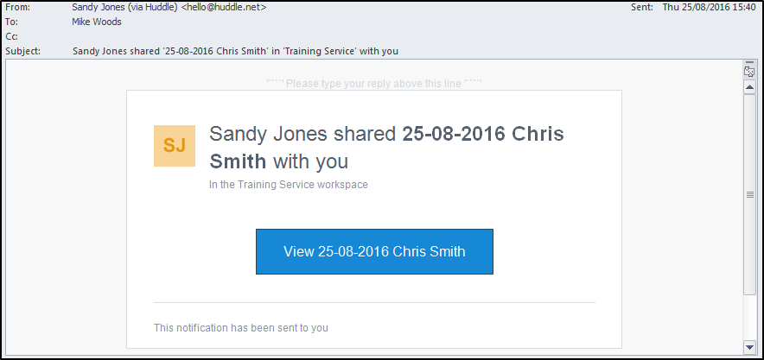
To transfer this recording to a case file in your File Room you will need to carry out the following steps.

Copy the recording from huddle
- Click the link in the email and log into huddle when the login screen opens.
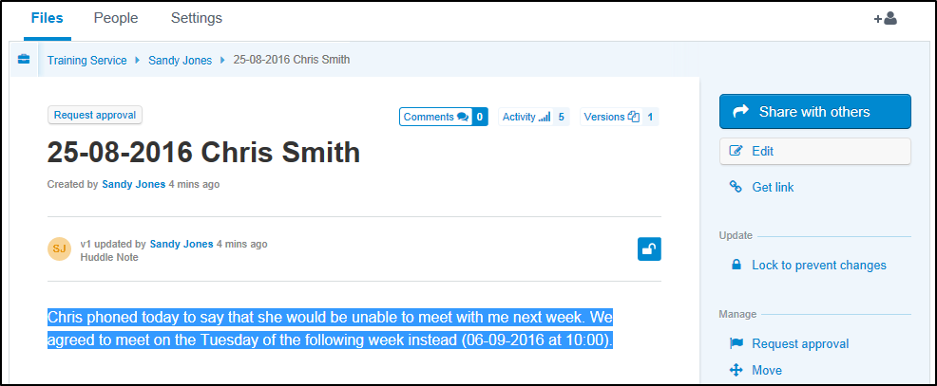
- Highlight all of the text in the recording.
- Copy the highlighted text by either:
  - Pressing Ctrl+C.
  - Right-clicking the highlighted text and selecting Copy.

Paste the recording into a new Text Document
- Open SUR and navigate to the Contacts and Ongoing Recording file divider in the relevant case file.
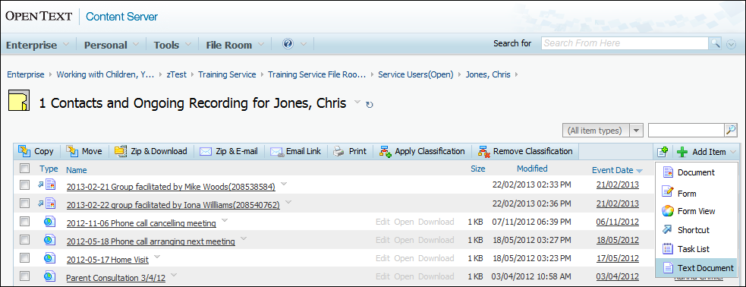
- Click the Add Item button.
- Select Text Document from the drop-down menu.
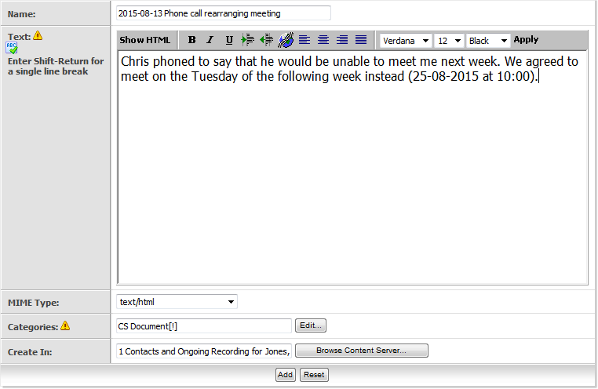
- Give the document a Name following the recording protocol for your service.
- Paste the recording into the Text area by either:
  - Pressing Ctrl+V.
  - Right-clicking in the Text area and selecting Paste.
- Save the recording and complete the Category information in the normal way.
Note: If you need guidance on using the SUR system, see the Service User Recording pages on b-hive.

Delete the recording from huddle
Once you have copied the recording into the case file, you must delete it from huddle.
Note: You may have been logged out of huddle while you were working in SUR. If so, just re-enter your password to return to the same screen.
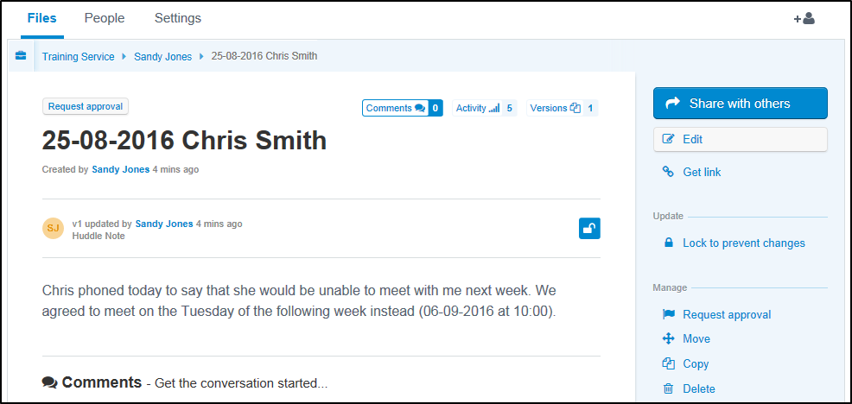
- Click the Delete link in the right-hand column.
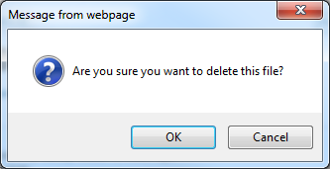
- Click OK to confirm the deletion.
You have now completed transferring that recording to SUR. You should repeat the above steps for each piece of recording to be transferred.

