Once a user has been invited to a workspace, this guide shows how a current manager of the workspace can make the new user a manager and then, optionally, remove their own access to the workspace.
Note: The new workspace manager must have already been invited to join the workspace. Inviting a user to the workspace is covered in a separate guide on the huddle b-hive page.

Making a user a workspace manager
- Navigate to your workspace.
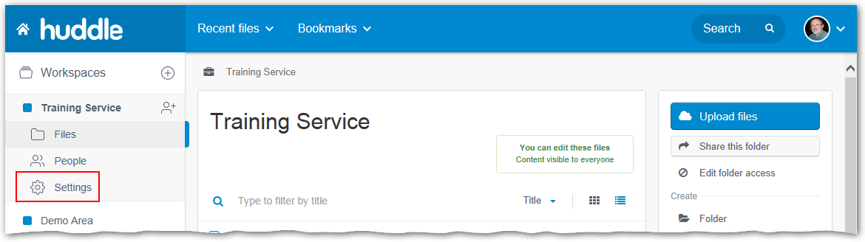
- Click the Settings tab in the left-hand panel.
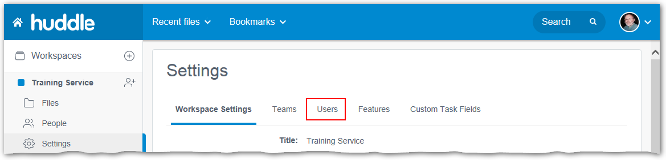
- Click the Users option.
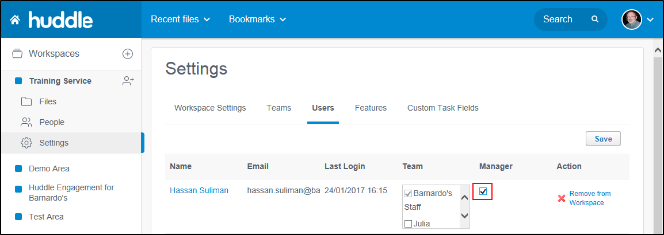
- Click the Manager tickbox for the new workspace manager.
- Click the Save button above the right-hand column.

Removing your own access to the workspace
Note: Only do this once you have completed all the tasks needed to transfer management to another user, as described above. As soon as you carry out the process below you will be prevented from accessing the workspace.
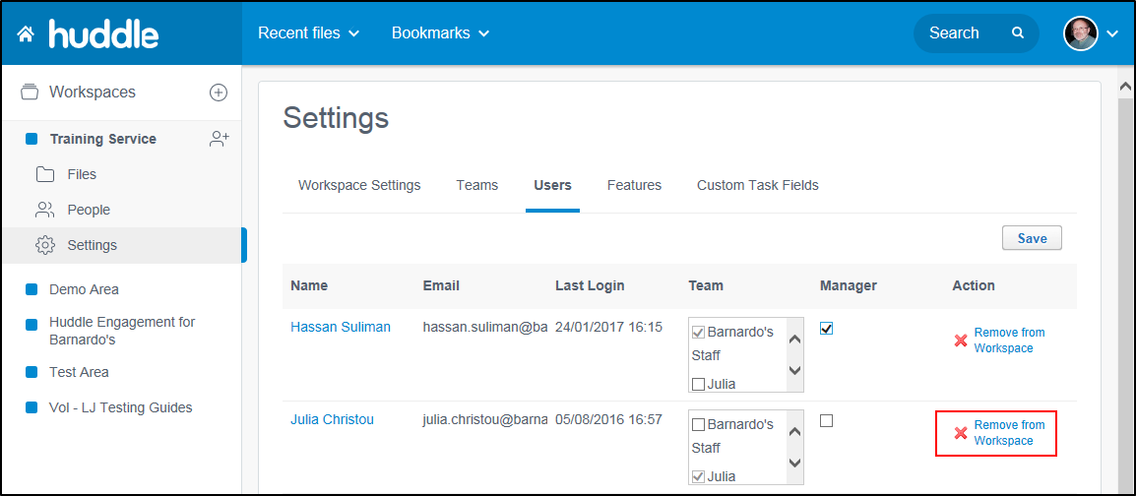
- Click the Remove from Workspace link for your login.
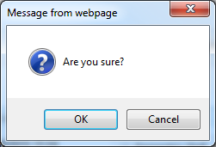
- Confirm the removal by clicking the OK button.

