Introduction
This guide will take you through the steps of how to connect your laptop, to a personal hotspot, on your mobile device. The personal hotspot can be used, when you do not have access to a Wi-Fi network. This process of connection is referred to as tethering.
Note: The following images have been taken from an iPhone 7 running iOS 10+, some of these images may differ slightly if using other iOS devices.
Set-up Wi-Fi Tethering
Make sure mobile data is switched on, as Personal Hotspot will not be available to select.
- Tap Settings >> Personal Hotspot >> Slide Personal Hotspot (this will change to green once on)
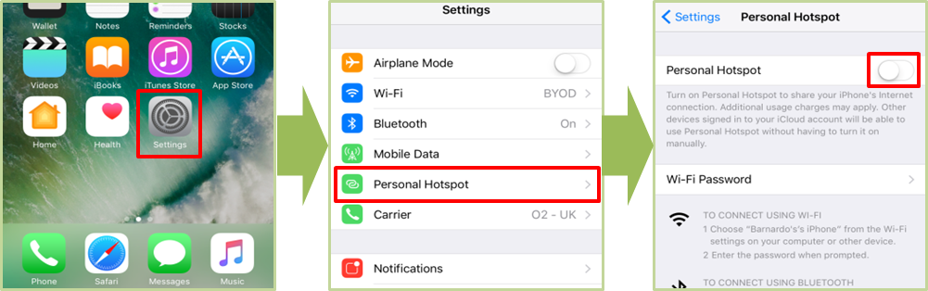

- Tap Turn on Wi-Fi and Bluetooth >> Note the Device’s Name and the Wi-Fi Password
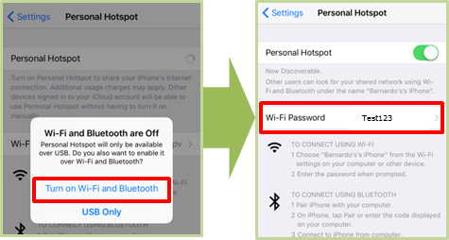
- Launch BTOne Mobile (this will be a desktop icon on your laptop)>> Click the green Wi-Fi symbol and select Private Wi-Fi
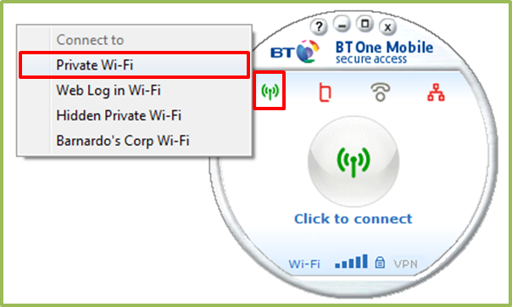
- Select the Wi-Fi network >> Enter the password
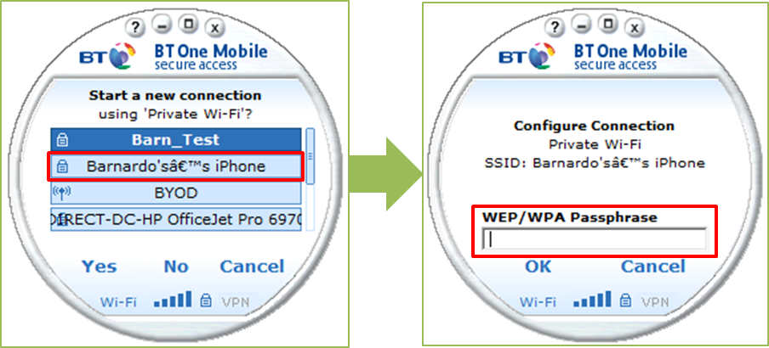
Note: The Network name and password are the same as the details added in the 2nd step of actions above.

- Enter your VPN User Name >> Enter your 4 digit PIN and password
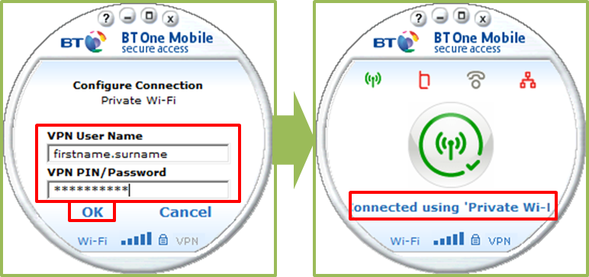
Note: This step on BT One Mobile may vary and you may only be required to enter your VPN Pin/Password.

