This guide will provide step by step instructions on how to create a sickness absence record in myPlace.
When an employee is absent due to ill health the sickness absence record must be created on the day it was reported with the start date (the first day of absence) and absence reason. Once the employee returns to work the end date (last day of sickness) and duration fields must then be entered. The manager can then start the return to work process.
Note: If the period of absence requires a GP certificate there are additional fields that need to be completed.
To create a sickness absence record:
- Log into myPlace.
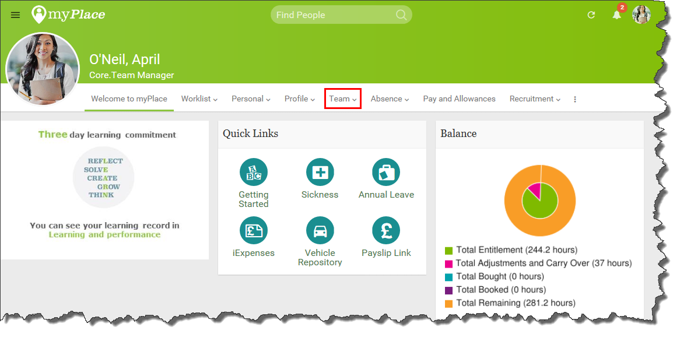
The myPlace welcome page will be displayed. As you can see myPlace has a Team menu where managers are able to access their Direct Reports and create a sickness absence record.
- Select Team then Team absence. The Team absence screen will be displayed.
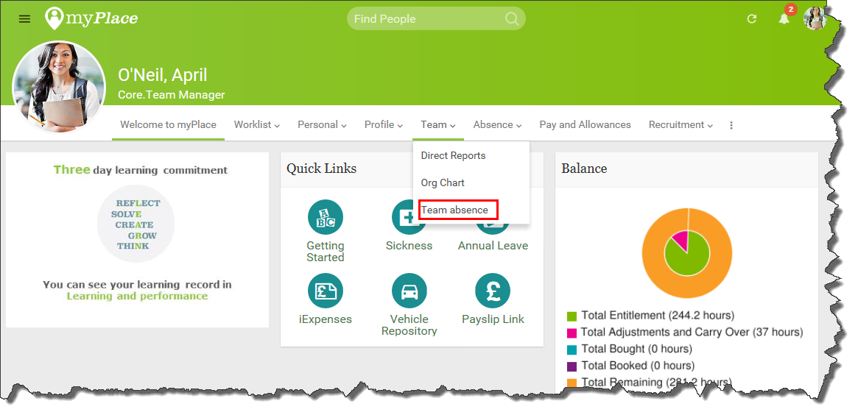
- Select Team absence
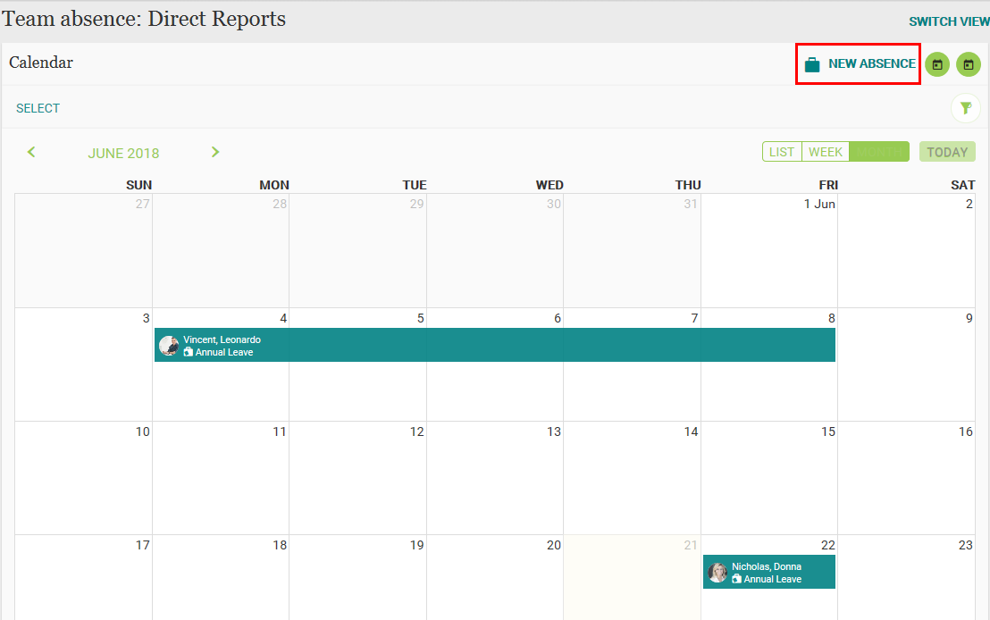
- Select New absence
The New absence screen will open.
Tip: Select a date or date range in the calendar then select New absence the new absence form will open and the date(s) will automatically populate.
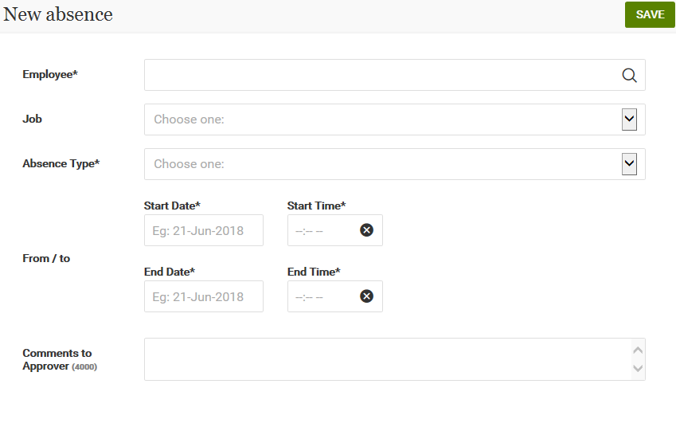
The sickness details screen will open.
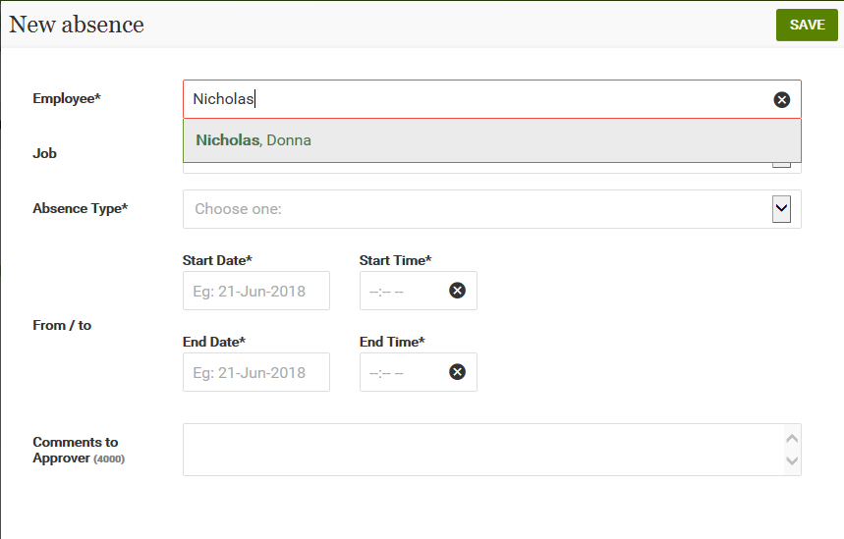
- In the Employee field search for the required direct report.
- In the Job field select your job.
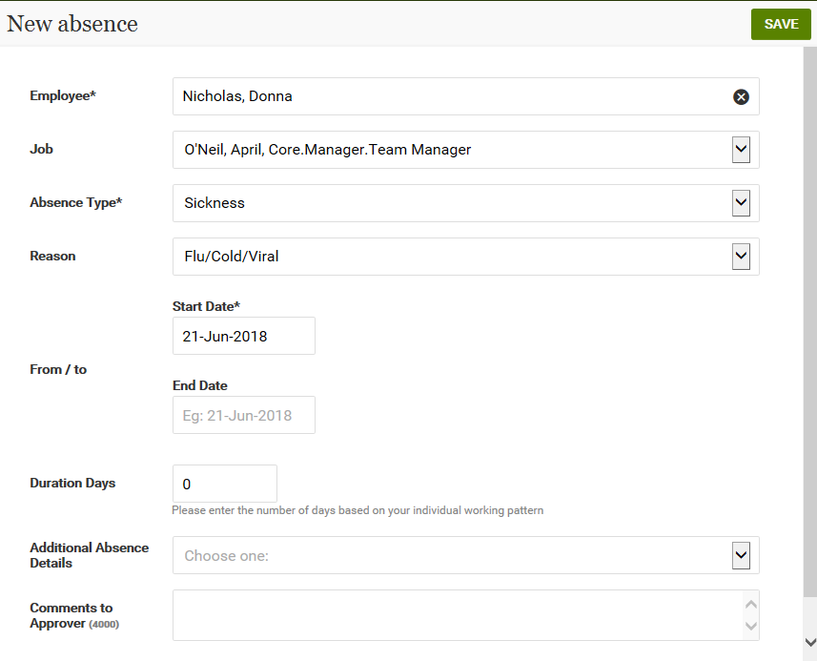
In the Absence Type field select Sickness from the drop down list. The details screen will expand showing additional fields.
- In the Reason field select the appropriate reason from the drop down list.
- Click in the Start Date field.
Note: The Start Date is the first day of sickness absence. Ensure you are familiar with the individuals work pattern, for example if weekends are part of their work pattern.
- Enter the Start Date. The end date will automatically populate.
Tip: Use the calendar to select the date.
- Remove the End date
Note: The end date should be populated when the employee returns to work. If this is being done after the employee has returned to work then enter the required end date.
Barnardo’s Additional Absence Details – GP Fit Note
Note: If sickness absence is longer than 7 days a GP Fit Note is required. The note should be scanned and saved to the employee’s electronic staff file, with a link sent to the local people team. The original should be returned to the employee.
If you information about a GP Fit note at this point please follow these additional steps before saving the sickness absence record.
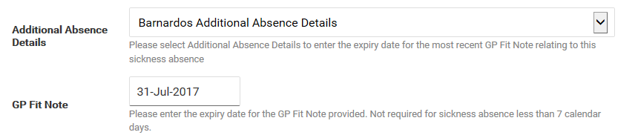
- In the Additional Absence Details field select Barnardos Additional Absence Details from the list. The GP Fit Note field will display.
- In the GP Fit Note enter the expiry date for the GP Fit Note.
- Select the Save button. The record will be saved.
Note: This is the end of the process until the employee returns back to work. It is imperative that this record is created on the first day the direct report is absent from work as it informs payroll of the Statutory Sick Pay (SSP).
When the employee returns to work:-
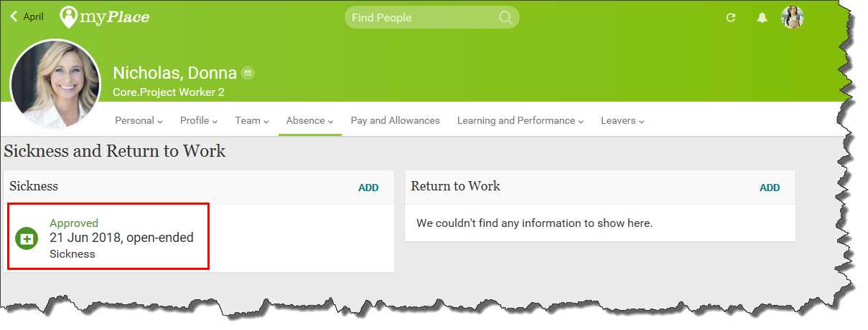
Note: To edit an open ended absence for a direct report navigate to the Team Menu then Direct Reports, select Absence then Sickness & Return to Work.
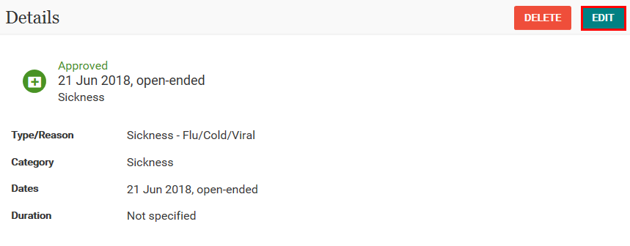
- Select the required record and click on the Edit button.
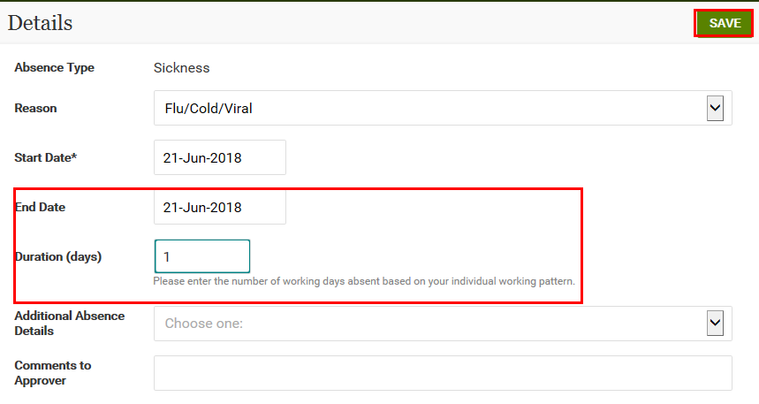
- Enter the End Date
- Enter the duration in days.
Note: The end date is the last day the employee was absent from work, not the day the employee returned to work. The duration is the number of days absent based on your employees working pattern.
Barnardo’s Additional Absence Details – GP Fit Note
Note: If sickness absence is longer than 7 days a GP Fit Note is required. The note should be scanned and saved to the employee’s electronic staff file, with a link sent to the local people team. The original should be returned to the employee.
If this information hasn’t already been entered, please follow these additional steps before saving the sickness absence record.
- In the Additional Absence Details field select Barnardos Additional Absence Details from the list. The GP Fit Note field will display.
- In the GP Fit Note enter the expiry date for the GP Fit Note.
- Select the Save button. The record will be saved.
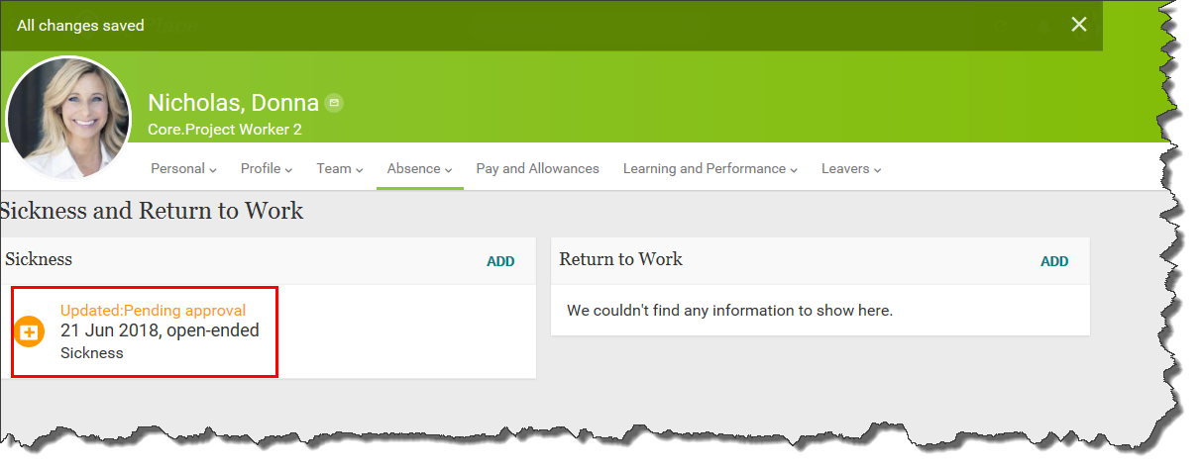
Note: The record will first appear as Pending Approval but will automatically change to an Approved record. Please note although the sickness record approves automatically it can take up to 5 minutes. To see the record has changed to Approved it is necessary to refresh the screen.
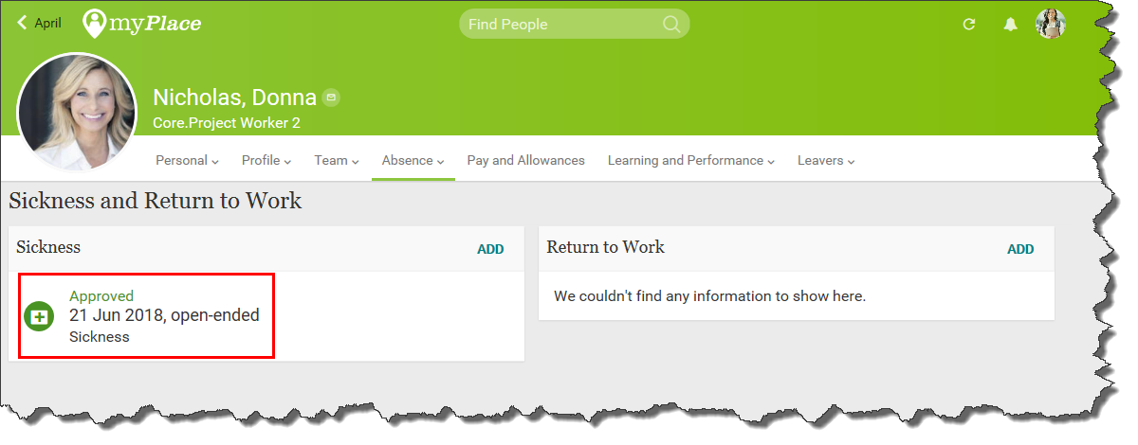

Note: if the record is entered by the direct report themselves then it will only change to an Approved record in green if it is approved by their line manager. Once a sickness absence record has an end date and has been saved it is no longer available to edit.
The return to work form can now be completed. See the myPlace Return to work form user guide for assistance.
The record will now be saved.

