This guide will provide you with step by step instructions on how to download the myPlace App for an Apple smartphone or Tablet.
To download the myPlace app from the App Store:
- Select the App Store icon.
- Select the Search icon.
- In the search screen type Applaud HCM
- Install the app
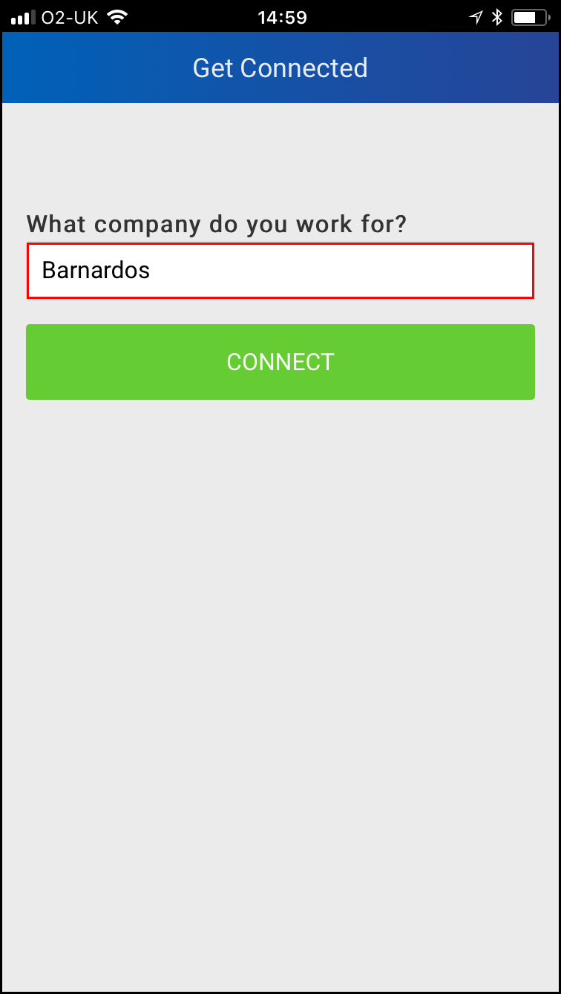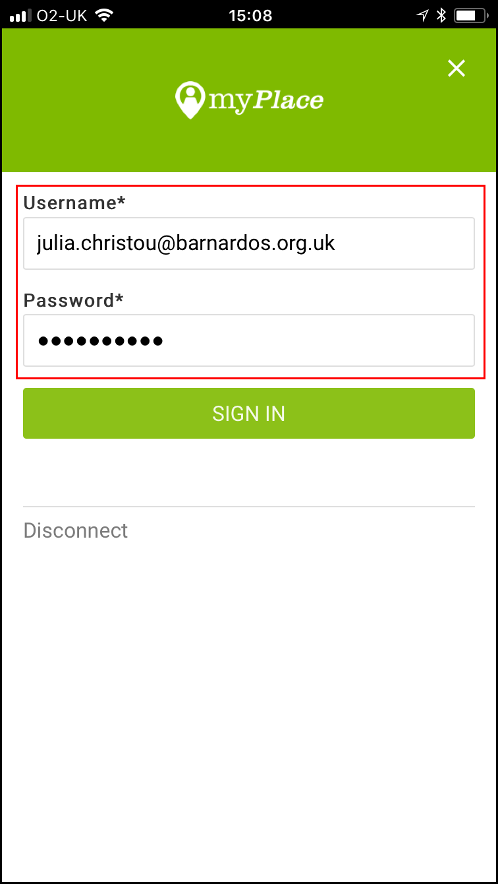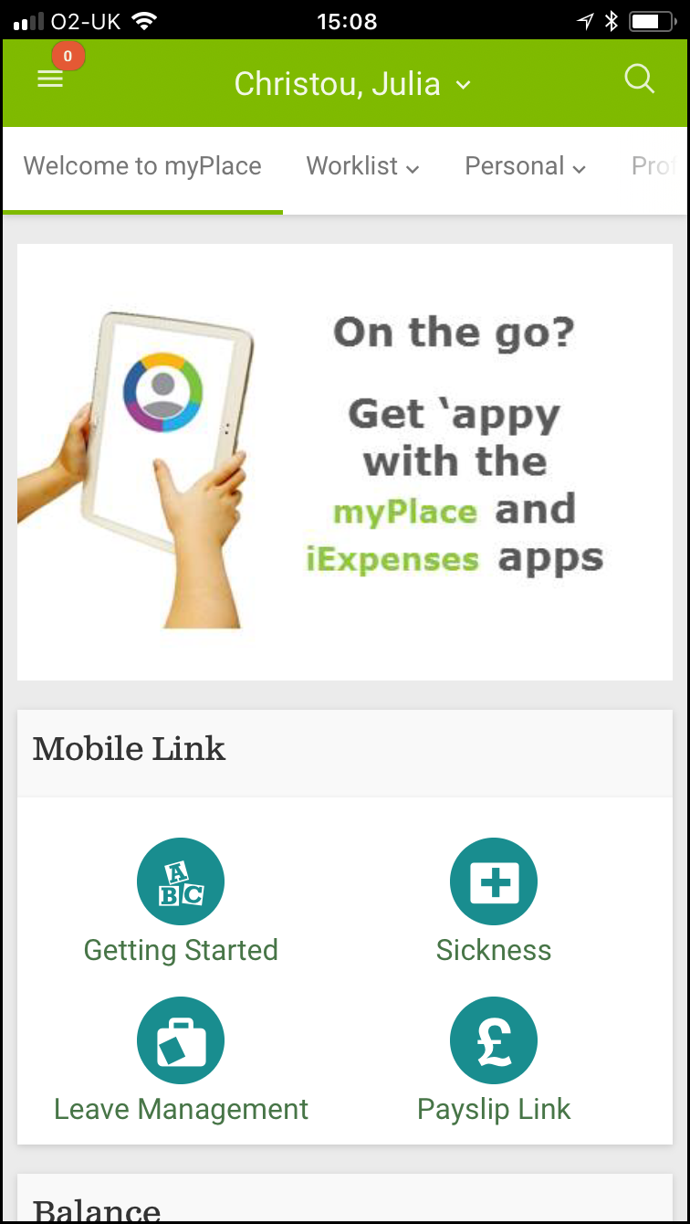
- In the What company do you work for? field enter Barnardos
- Select Connect. The Login screen will be displayed.
- Type in your myPlace credentials.
- Select the Sign In. The myPlace Welcome screen will be displayed.
Note: Your login name is your Barnardo’s email. Your password is your myPlace/Oracle password.
If you are using single sign on you will need to log into myPlace/Oracle first and reveal your password, this is what you need to use to sign into the myPlace app.

To Log out of the myPlace App:
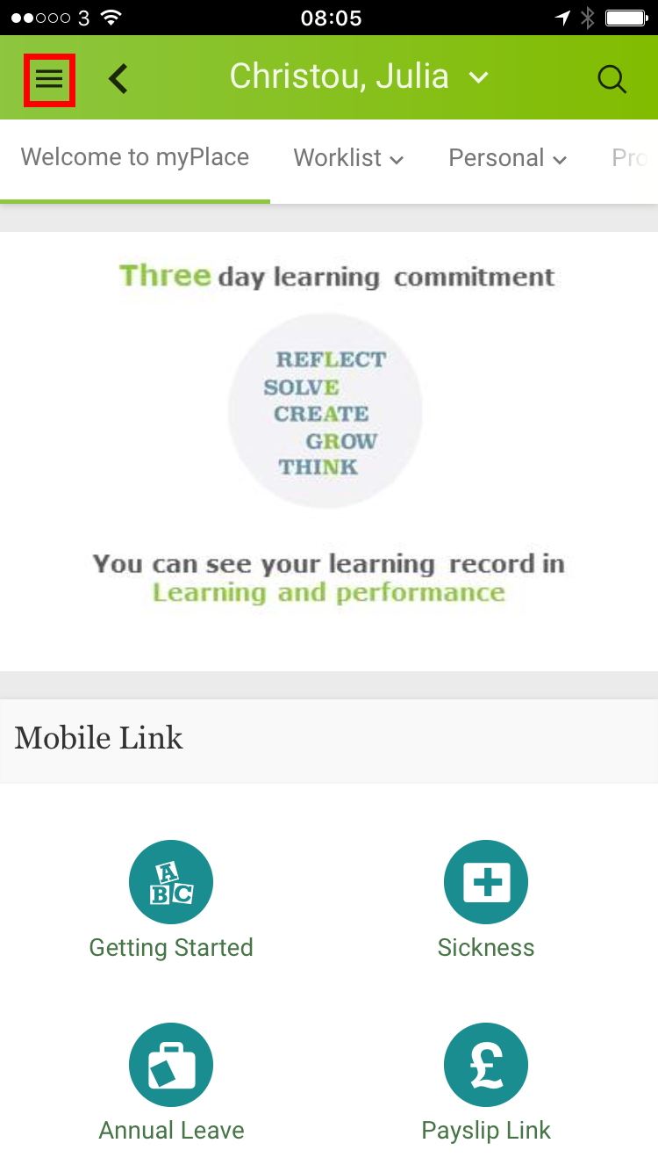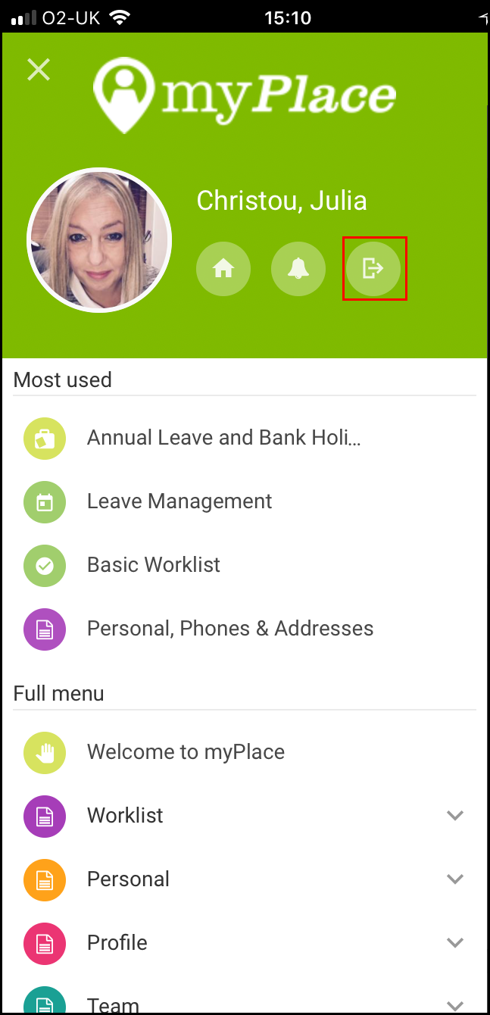
- Select the menu item. The sign out icon will be displayed.
- Select icon. Your myPlace session will end.
Note: To ensure that your personal data and work information about your colleagues is protected you should ensure that you Sign Out of myPlace and ensure that your device is PIN Code protected.
Tip: It is best practice to end the app so that it is not running in the background.
Once you have downloaded the myPlace App the app will appear on your smartphone or tablet homepage. You will need to login using your Barnardo’s credentials every time you use the app.

